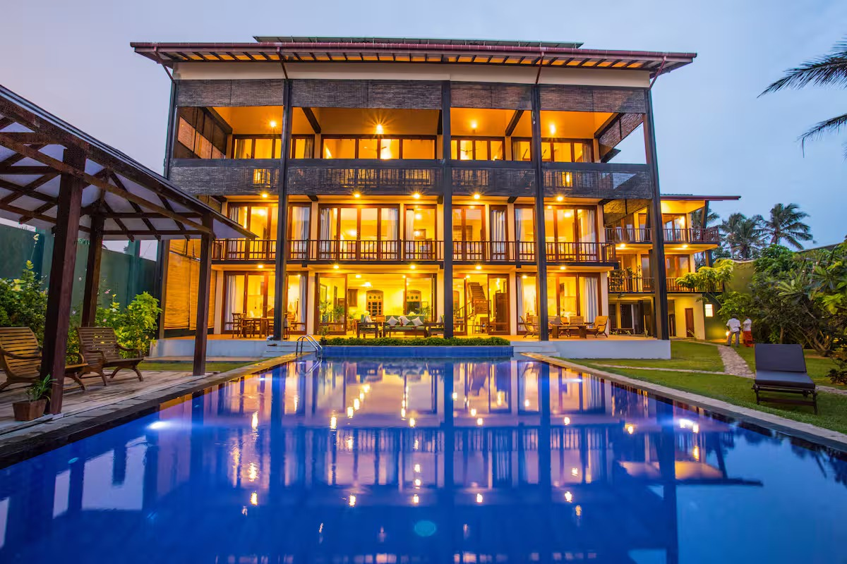
The Healing Temple Presents
Ocean Soul Retreat
Sri Lanka
____________________________________________________________________________
Ahangama, Southern Province

Dates
October 23–30, 2028
Arrival from 13:00 -- Departure by 10:00

About the Destination
Ahangama, located on the southern coast of Sri Lanka, is known for its golden beaches, warm ocean waters, and relaxed tropical atmosphere. The area offers a beautiful blend of nature and culture — from coral reef swimming spots and surf beaches to nearby heritage sites and tea plantations. With a slower pace of life, ocean views, and lush surroundings, Ahangama provides the perfect setting to unwind, reconnect, and recharge.

The Villa Experience
You will be staying in a private beachfront villa designed to offer both comfort and a deep connection to the natural surroundings. The villa features 11 air-conditioned bedrooms with ensuite bathrooms, combining antique charm with modern comfort. Spacious indoor and outdoor living areas open out onto uninterrupted ocean views, creating a seamless flow between the villa and the beach. The villa is thoughtfully designed across a main house and adjoining spaces, with rooms distributed throughout to offer a balance of connection and privacy. Some rooms are located in a quieter section of the villa, directly connected to the main living and pool areas, providing a more peaceful and private setting.
A private swimming pool, daily housekeeping, and a fully staffed team — including a private chef — ensure a relaxed and effortless stay. With direct access to a soft sandy beach and calm reef-protected waters ideal for swimming and snorkelling, the villa offers a unique and immersive coastal experience.
This space has been carefully chosen to create a sense of calm, openness, and ease, supporting you to slow down, reconnect, and fully immerse in the retreat.

Retreat Experience
This retreat offers a balance of movement, healing, and free time. Each day is gently structured to support your wellbeing, while allowing space for rest, reflection, and personal choice. This retreat is designed to help you slow down, reconnect with your body, and release emotional tension, while creating space for clarity and inner grounding.
A typical day may include:
- Morning meditation & yoga
- Nourishing breakfast
- Free time / beach / treatments
- Afternoon session or excursion
- Evening dinner & integration
This retreat is for you if:”
- you feel overwhelmed and need space
- you’ve been holding too much for too long
- you want to reconnect with yourself in a grounded, real way

What’s Included
This retreat is all-inclusive, with the exception of one optional restaurant meal.
Three nourishing meals daily prepared by a private chef
Drinks, snacks, and fresh fruit throughout the day
Daily yoga and meditation
StarDance (somatic dance)
Cacao and fire ceremonies
Group healing sessions
Two massages per person
One group excursion
Restaurant visit (meal not included, one drink included)
Daily housekeeping
Airport transfers
Local transport support
Concierge support
WiFi
Optional excursions and additional treatments are available.

Accommodation
The villa offers a range of beautifully designed bedrooms. Shared accommodation is included, with single occupancy available on request.

Travel Information
Guests are recommended to fly into Bandaranaike International Airport (Colombo).
Transfers from the airport to Ahangama take approximately 2 to 2.5 hours by private vehicle and are included in the retreat. We will coordinate group transfers based on arrival times closer to the retreat.
A dedicated WhatsApp group will be created prior to the retreat to support communication, travel coordination, and any questions you may have before and during your stay. Guests are also welcome to connect within the group to arrange flights or travel together if they wish.
Your Hosts
This retreat is held by Guiomar and Shelley.
Guiomar is a holistic therapist with over a decade of experience, working with meditation, sound, and emotional integration.
Shelley is an experienced yoga teacher with two decades of practice, offering grounding and restorative movement sessions.
Together, they create a safe and supportive space for transformation and connection.

Investment
£2,300 per person (shared accommodation)
Single occupancy: £2,750
A limited number of spaces are available for this retreat.

Payment Plan
A £500 deposit per person secures your place. The remaining balance is spread over a flexible 18-month payment plan via direct debit, starting December 2026, making it simple and manageable.
Shared Room
Total: £2,300
Deposit: £500pp
Balance: £1,800
Monthly: £100 (18 months)
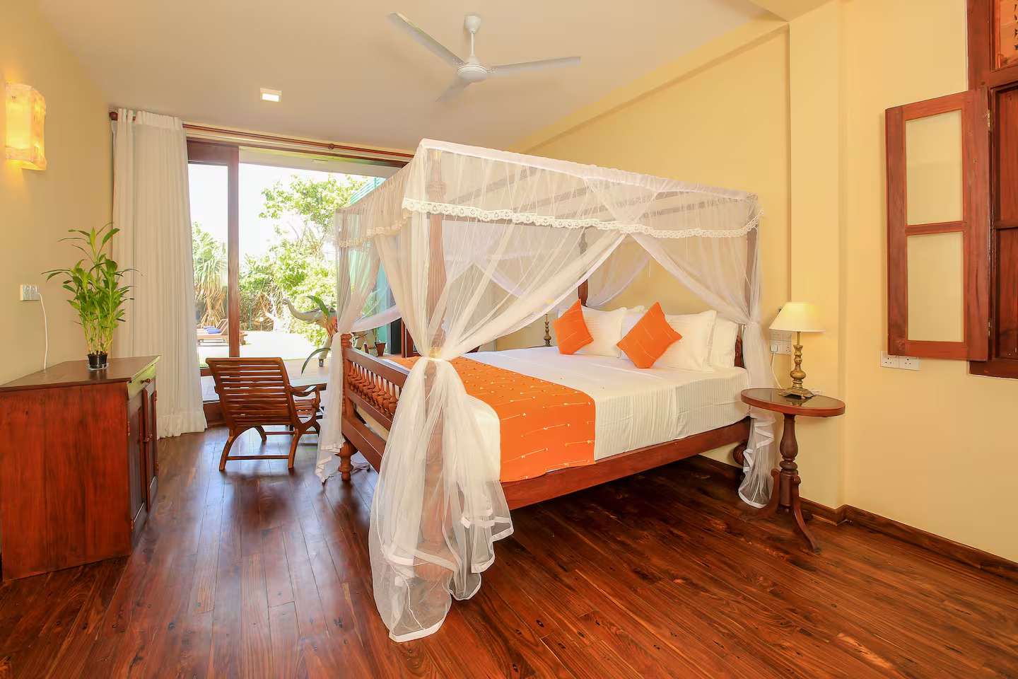
Single Room
Total: £2,750
Deposit: £500
Balance: £2,250
Monthly: £125 (18 months)
If you feel called to join this retreat, please get in touch to reserve your space.
EMAIL: thehealingtemple@outlook.com
Before booking, please read the Terms & Conditions

