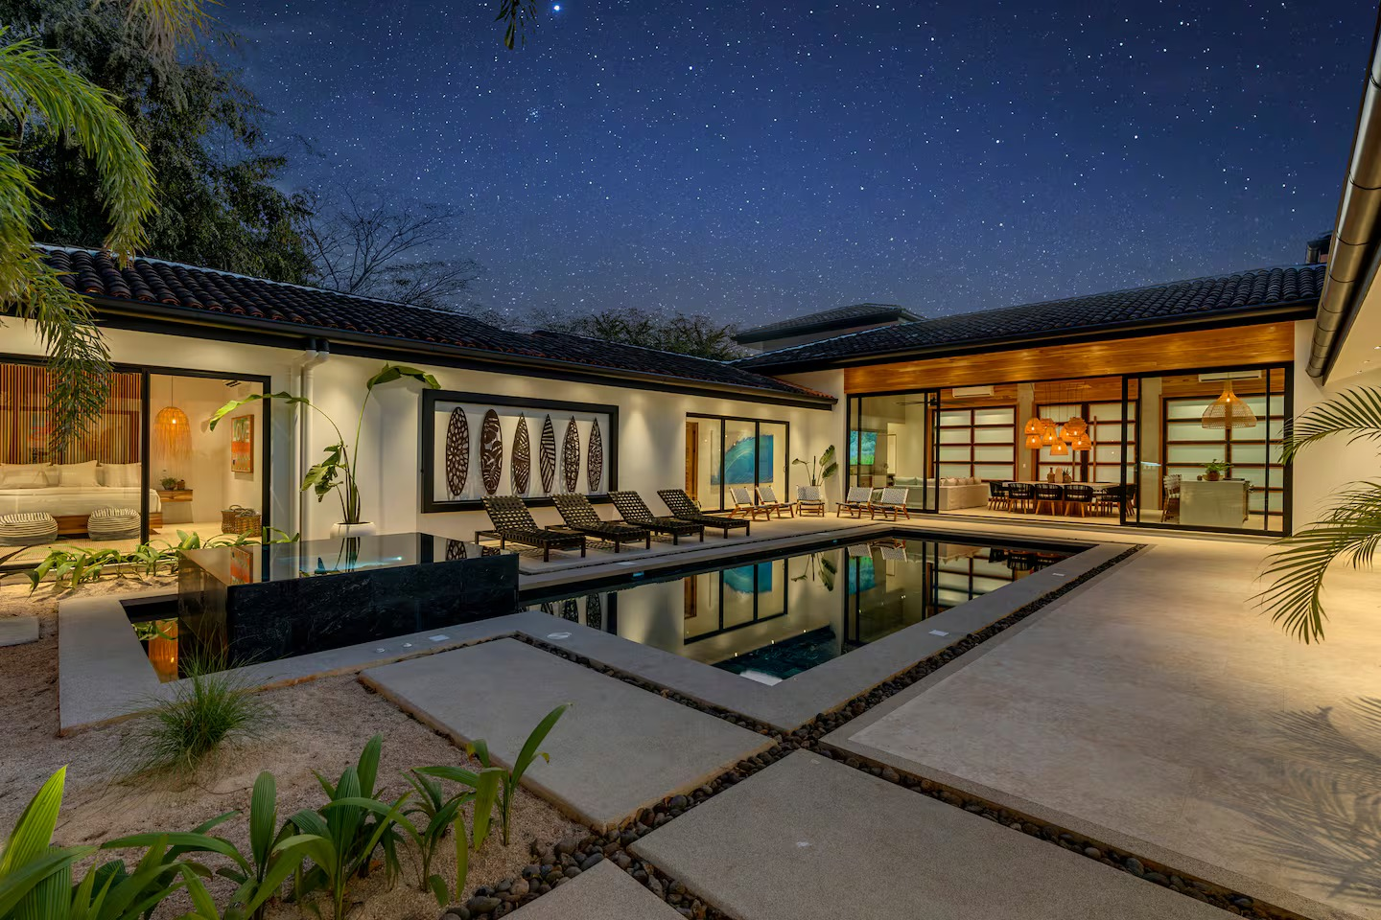
The Healing Temple Presents

Soul & Sea Retreat
Costa Rica

Tamarindo, Guanacaste

Dates

August 19–26, 2028
Arrival from 16:00 · Departure by 10:00

About the Destination
Nestled on the Pacific coast of Costa Rica, Tamarindo is known for its warm ocean waters, golden beaches, and relaxed tropical atmosphere. Located within the exclusive Hacienda Pinilla community, the area offers a unique blend of nature and comfort — from lush landscapes and wildlife to world-class beaches and surf spots.
With miles of coastline, scenic trails, and breathtaking sunsets, Tamarindo is the perfect setting to unwind, reconnect, and recharge.

The Villa Experience
You will be staying in a beautifully designed luxury villa, where modern architecture meets the natural beauty of Costa Rica. Built around a central pool and open-air living spaces, the villa creates a seamless connection between indoor comfort and the tropical surroundings.
Natural materials and thoughtful design details create a warm, grounding atmosphere throughout. The space has been carefully curated to offer a sense of calm, openness, and effortless living — the perfect environment to slow down, reconnect, and fully immerse yourself in the retreat experience.
Spacious indoor and outdoor areas invite both connection and quiet moments, whether relaxing by the pool, enjoying shared meals, or taking time for yourself.
Daily housekeeping ensures a comfortable and stress-free stay, while a dedicated concierge team is available to support your experience throughout the week.
You will also have access to the exclusive Hacienda Pinilla Beach Club, where you can enjoy the ocean, pool, and beachfront dining in a beautiful natural setting.

Retreat Experience
This retreat offers a balance of movement, healing, and free time. Each day is gently structured to support your wellbeing, while allowing space for rest, reflection, and personal choice. A week to slow down, reconnect, and come back to yourself — held by nature, movement, and meaningful connection
This retreat is for you if:
- you feel overwhelmed and need space
- you’ve been holding too much for too long
- you want to reconnect with yourself in a grounded, real way
A typical day may include:
- Morning meditation & yoga
- Nourishing breakfast
- Free time / beach / treatments
- Afternoon session or excursion
- Evening dinner & integration

What’s Included
This retreat is all-inclusive, with the exception of one optional restaurant meal.
Three nourishing meals daily prepared by a private chef
Drinks, snacks, and fresh fruit throughout the day
Daily yoga and meditation
StarDance (somatic dance)
Cacao and fire ceremonies
Group healing sessions
One group excursion
Restaurant visit (meal not included, one drink included)
Daily housekeeping
Airport transfers
Concierge support
WiFi
Optional massages available

Accommodation
The villa offers a range of beautifully designed bedrooms. Shared accommodation is included, with single occupancy available on request.

Travel Information
Guests are recommended to fly into Liberia International Airport (LIR), which is the closest airport to the villa.
Transfers from Liberia Airport to Tamarindo take approximately 1 hour 15 minutes to 1.5 hours by car or private shuttle and are included in the retreat.
We will coordinate group transfers based on arrival times closer to the retreat.
A dedicated WhatsApp group will be created prior to the retreat to support communication, travel coordination, and any questions you may have before and during your stay. Guests are also welcome to connect within the group to arrange flights or travel together if they wish.

Your Hosts
This retreat is held by Guiomar and Shelley.
Guiomar is a holistic therapist with over a decade of experience, working with meditation, sound, and emotional integration.
Shelley is an experienced yoga teacher with two decades of practice, offering grounding and restorative movement sessions.
Together, they create a safe and supportive space for transformation and connection.

Investment
£2,500 per person (shared accommodation)
Private room upgrade: £2,980
A limited number of spaces are available for this retreat.

Payment Plan
A £500 deposit per person, secures your place. The remaining balance is spread over a flexible 18-month payment plan via direct debit, starting December 2026, making it simple and manageable.
Shared Room
Total: £2,500
Deposit: £500pp
Balance: £2,000
Monthly: £111 (18 months)
Single Room
Total: £2,980
Deposit: £500
Balance: £2,480
£2,480 ÷ 18 = £137.78
If you would like to share a room, you are welcome to join with a friend or we can match you with another guest.
Before booking, please read Terms & Conditions

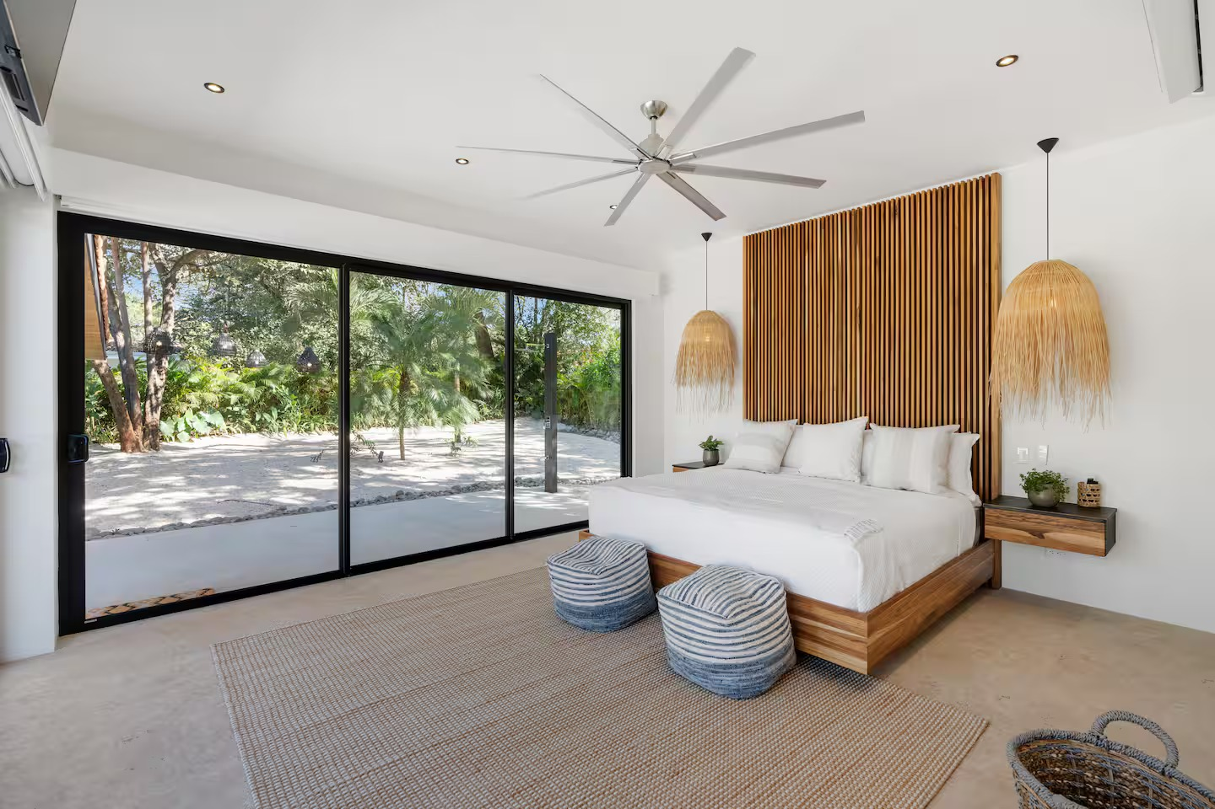
If you feel called to join this retreat, please get in touch to reserve your space.

EMAIL: thehealingtemple@outlook.com

